H.T No
Regulations:
A22

Sreenidhi Institute of Science and Technology
(An Autonomous Institution)
Code No:9HC12 Date: 31-August-2024 (FN)

B.Tech I-Year II- Semester External Examination, August-2024 (Regular & Supplementary)
ADVANCED CALCULUS (COMMON to ALL)

Time: 3 Hours Max.Marks:60

Note: a) No additional answer sheets will be provided.
b) All sub-parts of a question must be answered at one place only, otherwise it will not be valued.
c) Missing data can be assumed suitably.
Bloom's Cognitive Levels of Learning (BCLL)

Remember | L1 | Apply | L3 | Evaluate | L5
Understand | L2 | Analyze | L4 | Create | L6

Part - A Max.Marks: 6x2=12

Answer all QUESTIONS, EACH QUESTION CARRIES 2 MARKS.

 |  | BCLL | CO(s) | Marks
1 | Calculate the first order partial derivatives 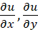 where | L2 | CO1 | [2M]
2 | Evaluate the integral . | L3 | CO2 | [2M]
3 | Form the differential equation for where 𝑓 and 𝑔 are arbitrary functions. | L3 | CO3 | [2M]
4 | Define Fourier Series. | L1 | CO4 | [2M]
5 | Calculate where | L2 | CO5 | [2M]
6 | State Gauss divergence theorem. | L1 | CO6 | [2M]

Part – B Max.Marks: 6x8=48
ANSWER ALL QUESTIONS. EACH QUESTION CARRIES 8 MARKS.

 |  | BCLL | CO(s) | Marks
7. | If 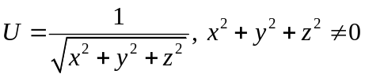, then prove that 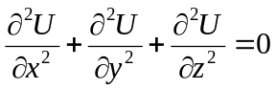 | L3 | CO1 | [8M]
 | OR
8 | Examine for extreme values, if any, of the function  f(x, y) = x³ + 3xy² - 15x² - 15y² + 72x | L4 | CO1 | [8M]
9. | i) Evaluate the integral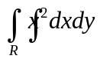 over the region ‘R’ bounded by  ii) Evaluate the integral | L3  L3 | CO2 | [8M]
 | OR
10 | Evaluate the triple integral 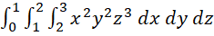 | L3 | CO2 | [8M]
11 | i). Form the partial differential equation by eliminating the arbitrary constants from 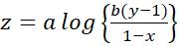  ii). Solve Lagrange’s linear equation | L3  L3 | CO3 | [8M]
 | OR
12 | Solve the differential equation . | L3 | CO3 | [8M]
13 | Find Fourier series expansion of the function  in Hence show that . | L3 | CO4 | [8M]
 | OR
14 | Obtain Half range Fourier cosine series expansion of and hence show that 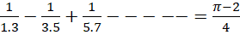 | L3 | CO4 | [8M]
15 | i) Find the directional derivative of f(x,y,z) = xy² + xyz + zx along the direction of the vector at the point (1, 2, 0).  ii) Show that the vector function  is irrotational. | L3  L3 | CO5 | [8M]
 | OR
16 | Show that the vector field defined by F = yzi + zxj + xyk is irrotational and find its scalar potential. | L3 | CO5 | [8M]
17 | Make use of Green’s theorem in a plane to evaluate the line integral 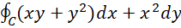, where  encloses the region bounded by and | L4 | CO6 | [8M]
 | OR
18 | Verify Stoke’s theorem for taken round the rectangle bounded by the lines x=±a, y=0 and y=b. | L4 | CO6 | [8M]

-- 00 -- 00 –

